

Dear Parents, Carers and friends of our school,

Firstly, a massive thank you to everyone for making me feel so very welcome throughout the past month. I knew that I was joining a fabulous school and community but I have been overwhelmed by the kindness and thoughtfulness of everyone. I have received many pictures, letters and cards from pupils – one which said, “I hope you feel part of our school very soon.” I can confirm that I do and I feel very proud and privileged to be.

This newsletter aims to keep you up-to-date with the happenings in and around school. If there is anything missing from our newsletters then please let us know. I also always attach a “Have Your Say” page which provides readers of our newsletter the opportunity to feedback any views/opinions etc.

Many thanks, Mr P.R.Rooke

C:\Users\prooke\AppData\Local\Microsoft\Windows\Temporary Internet Files\Content.Outlook\X5ZKWSXZ\DSC_0540a.tif

**Road Safety** is so crucially important and we were delighted to welcome our friends from Police Scotland who worked with all P1-3 children. The girls and boys listened so very well to the helpful advice while also having some fun with the officer’s uniform and equipment!

**Staff News** I am delighted to inform you that Mrs MacIver has had a baby boy. Ruairidh was born on 18/02/2015. I am sure you will join us in wishing the family well.

We have also said “goodbye and best wishes” to Mrs Aldus who commences her maternity leave this week. We wish her a restful time before her baby joins us. At this point in time, Mrs Wright and Miss McDonald will continue to work alongside P6.

Earlier this month, we were delighted to welcome Mrs Smart, our new clerical assistant, to the team. Mrs Smart will work alongside Mrs Forsyth at the front office Monday to Friday, mornings only.

**Sainsburys Active Kids 2015** is now up and running and vouchers can be collected from stores and online until Tuesday 5th May. We have a collection box in our reception and we would be delighted to receive vouchers from families and friends of the school.

More information can be found at [www.activekids.sainsburys.co.uk](http://www.activekids.sainsburys.co.uk)

**New Machar**

**School News**

February 2015

[](http://www.comicrelief.com/)

**Comic Relief** is back on Friday 13th March 2015 with the theme of *Make your face funny for money!* Our Pupil Council are currently planning and organising our fundraising effort and more information will be sent out to families very soon.

**Red Noses will be on sale at school.**

**Polite reminders and other information**

* In our efforts to maintain pupil safety and security, I would request that nursery parents/carers remember to close the gate after entry and exit.
* I also need to remind everyone that dogs are not permitted within school grounds nor should they be tethered near to pupil areas.
* I am very impressed with the level of school uniform at New Machar. However, I feel that there is still room for improvement at the senior end of our school.
* Due to some comments and concerns around security and safety, we need to look at the entrance arrangements at the beginning of the school day. I will write soon to advise families of some necessary adjustments.

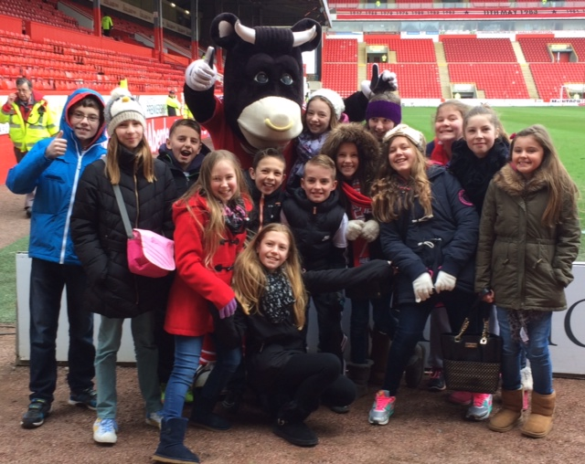

**Well done Sol!** One of my first official outings with New Machar School was a visit to Pittodrie. This was, not only to watch the mighty Dons thrash Ross County 4-0, but more importantly to join Sol in celebrating his winning design in the mascot competition. Sol was on the pitch at half-time as Donny the Sheep was unveiled.

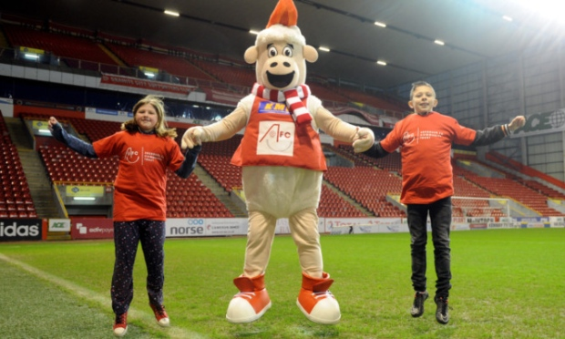

**Upcoming Events**

* Our P3/4 and P4 classes will be undertaking library visits. P4 on Tuesday 24th February and P3/4 on Thursday 26th February both at 1.30pm.
* Our Parent Council Meeting is on Tuesday 24th February at 6.30pm.
* An exciting opportunity for P1/2 and P2 pupils on Monday 2nd March as we will be visited by the Cosmic Dome – I hope I can get through to see this!
* Friday 13th March is Red Nose Day.
* On Wednesday 18th March, P2 pupils will visit Satrosphere. I am certain that this will be an enjoyable and interesting outing.
* Parent Council Easter Event will be held on Tuesday 24th March, further information coming soon.
* Our term ends on Thursday 2nd April 2015.

**Ski Trip 2015**

Earlier this month our P6 pupils hit the slopes and rather than me try to tell you about something that I was not fortunate enough to experience, I will leave it up to Euan (P6) to tell you…

*At the ski trip when we first arrived we got on all of our gear (ski boots, skis) and we headed for the starter slopes. We learned how to get our skis on and off, how to get on the ski lift and how to do a snowplough.*

*After the tiring day we all headed off for our places we were staying, Gulabin and Compass. At night we all watched a movie. At Compass, we watched Over the Hedge and at Gulabin, they watched Flushed Away. We all got up to bed after that and after we had to change into our ski clothes and have breakfast and fill our flask and after we headed for the slopes for another busy day of skiing.*

I know from speaking with the pupils that they thoroughly enjoyed their ski experience. I was so pleased to hear the success stories of our skiers at all levels. I now feel inspired to give it a go myself, so maybe I’ll get to go next year!

Importantly, I would also like to take an opportunity to thank all adult helpers as without them our pupils simply would not get this amazing experience.

Your ideas, views and opinions are very important to our school. If you would like to comment on any of the items within this newsletter or anything else, please do so below and return this page to the school office. Alternatively, you can email us at **newmachar.sch.aberdeenshire.gov.uk** with *Have Your Say* as the subject heading.

Many thanks!

Your Child’s Name and Class (optional)

Your name and relationship to child (optional)

Comments -

**Have Your Say!**

February 2015