

**Staff News**

I am delighted to inform you that Mrs Kinghorn has had a baby boy. Luke was born on 25/04/2015. I am sure you will join us in wishing the family well.

Mrs Wright is now looking after P2/3 until the end of session and we have Mrs Metcalfe supporting our nursery youngsters. We are extremely grateful for the flexibility and willingness of staff.

We also have Mrs Smith working on Thursdays and Fridays in P6. This is essential to enable Miss McDonald time to carry out important DHT responsibilities and again we are very grateful for this.

**Request for Dressing Up clothes**

I have a request from our early years’ staff. We are looking for dressing up clothes for our youngest pupils. If you have any items that are no longer any use to you, we would very much appreciate them at school. We are looking for fairy tale themed clothing e.g. pirates, dragons, knights, princes and princesses.

**Important Safety Reminder**

All pupils who cycle to school should be sure that bikes are in good working order and that protective helmets are worn.

**No helmet = no cycling to school!**

**Parent Council News**

Thank you to Mr Rooke for giving the Parent Council the opportunity to provide a contribution to the newsletter.

Thank you all for coming along and supporting the Easter Eggstravaganza, we are delighted to announce that £592.00 was raised. The pupil council did an amazing job organising stalls and helping on the night.

This is the busiest term for the Parent Council with the AGM being held on 5th May and the annual Summer Fayre on 6th June. New members are always welcome and we’d be delighted to see new parents at any of our meetings. The Summer Fayre is the biggest fundraiser for the school and we thank everyone for their support. Watch the Facebook page and any notes your child brings home as we will be looking for volunteers to man the stalls and help set up! If you can’t make it along to the meetings but have something you’d like discussed please let your class representative know.

Current Class Representatives

Nursery – Annie Robinson, Suzanne Rydlewicz

P1 – Laura Martin, Ashley Ross

P2 – Kerry Donald, Kerry Stewart

P3 – Lawrence Thirkell, Kate Metcalfe

P4 – Marie Campbell

P5 – Hazel Brodie

P6 – Emma Pirie, Kerry Murray, Rhona Kennedy

P7 – Lorraine Christison, Rob Bain

**Morning Entry Arrangements**

Many thanks to everyone who provided very useful feedback both verbally and in written form.

Having assessed and evaluated the new arrangements for morning entry, we will continue with this for the duration of summer term. I very much appreciate your support and understanding with this matter.

Dear Parents, Carers and friends of our school,

Term 4 already…how did that happen? I hope that everyone enjoyed a well-deserved Easter break. I have been inundated with stories of fun times at home and trips away, so I hope we are all now suitably refreshed and raring to go for summer (19 degrees when I started writing this and now it’s a white-out!) term. As you will imagine, it is going to be a busy time ahead and we aim to keep you right up to date with what has happened and what is yet to come.

Many thanks, Mr P.R.Rooke

**New Machar**

**School News**

April 2015

Our School Website Needs YOU!

We are looking to update and improve our school website and we are very interested in hearing what you would like to see featured on it.

Our website can be found at [www.newmachar.aberdeenshire.sch.uk](http://www.newmachar.aberdeenshire.sch.uk)

Please feedback any ideas/suggestions, either via the Have Your Say Sheet or email us at [newmachar.sch@aberdeenshire.gov.uk](mailto:newmachar.sch@aberdeenshire.gov.uk)

with *Have Your Say* as the subject heading.

**Working together at New Machar**

I have been so very impressed with how well our pupils work together in their classes. However, this excellent piece of writing by Erin (P5/6) demonstrates how successful we can be at working across classes too!

Egypt was just such an interesting topic that both my class and Primary 3 chose to study it. A couple of weeks before the holidays, Mrs Stewart asked our class (since we are so awesome!) to create a puzzle sheet! She said that the P3s might not read all the information and that we could make it more fun! I was delighted to help the little ones!

Mrs Thomson split us into pairs and we read through the information first. Me and my partner, Ethan Main, laughed at some of the facts! Everyone had a little brainstorm to think what type of puzzle we could do. I settled on an everyday quiz sheet that included our most favourite facts. We wrote out our rough copy and put it on to the teacher’s desk. Two weeks later Mrs Thomson announced that we had lost the sheets! We were in such a panic as we would have to start again!

In all the hullaballoo, Callum Kelly and Matthew Brown spotted the sheets tucked in on the window sill! PHEW! After we made our new copies, we tried them out on the rest of the class.

Finally, on the last day of term, P5/6 and P3 joined together to complete the sheets. Both classes were excited and it was a great experience. I learned along with the P3s and loved the way they worked. I hope we join them again soon and have the same amazing outcome!

Erin Mehigan (P5/6)

**Staff doing their bit for charity!**

I thought that Mr Moir’s beard was simply him joining the recent “fashionable” craze! However, this beard is far more important than that! You may recall that Mr Moir chose to join Cash for Kids, Beards for Bairns in their fundraising effort between December and January. We would like to congratulate Mr Moir on raising a fantastic **£780**. Mr Moir would also like to thank everyone who very kindly contributed to this marvellous cause.

Mr Airey is now on the fundraising trail. He won’t be growing a beard though he’ll be…jumping out of a plane!

Mr Airey is raising money for MS Society Scotland and I am delighted to share the following link should anyone wish to contribute.

[www.justgiving.com/Campbell-Airey/](http://www.justgiving.com/Campbell-Airey/)

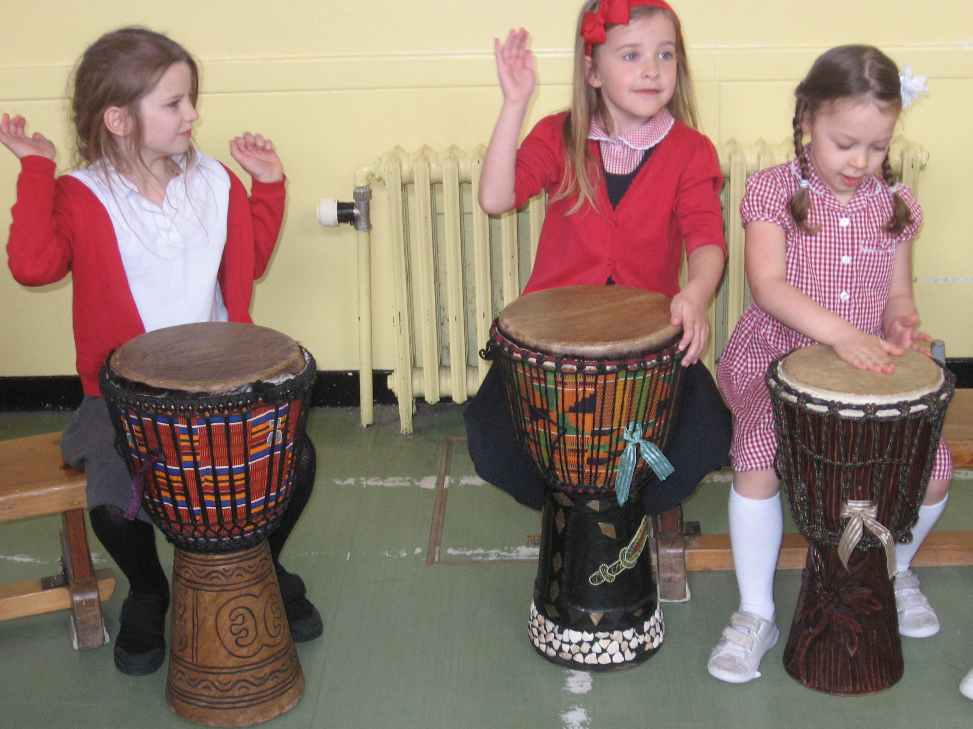

Our African Drumming experience has been fabulous. Children have been learning how to make beautiful music and not just a lot of noise! David, our drumming teacher, has been so impressed with our efforts and abilities. We have now planned for an end of project celebration event for the community which will be held in the Axis Centre. This will take place on Thursday 28th May 2015.

More information will come out very soon!

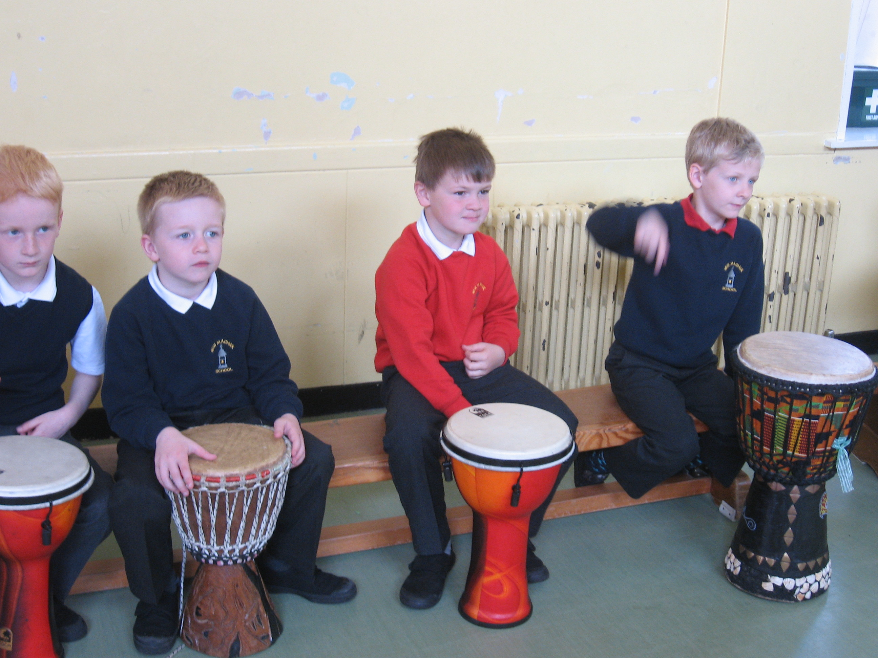

**National Champion!**

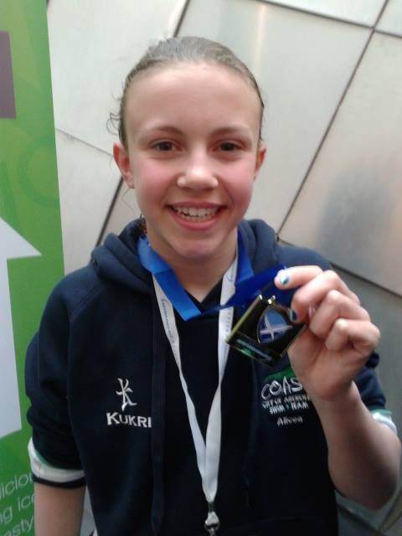

SNAGS (Scottish National Age Group Championships) is a competition for the top swimmers in Scotland. You have to meet the qualifying times to take part. It is a 5 day competition. This year it was held in Aberdeen. I competed every single day in over 15 different events. If I got through the heats in the afternoons, I qualified for the evening finals. These were all on TV which was exciting and meant my friends and family could watch too.

I reached 11 finals, which puts me in the top ten 11/12 year old swimmers in Scotland for those strokes and lengths. I finished with two 4ths, two 6ths, two 7ths, two 8ths, a 9th and a 10th place and also came first to become Scottish National Champion in the 4x100 Freestyle Relay.

It was really tiring swimming over 5 afternoons and evenings but really good fun. I was very nervous. It was good having Mr Rooke, Katie, Ellie, Hannah and Elise come and support me from school one afternoon.

If I finish in the top 23 in Britain I get through to the British Nationals. I have so far got 2 possible British times but I can lose them if anyone does better than me, but I hope not!

**Alicea (P7)**

We are extremely proud of Alicea and I am sure we’ll be hearing much more about her swimming successes in the future!

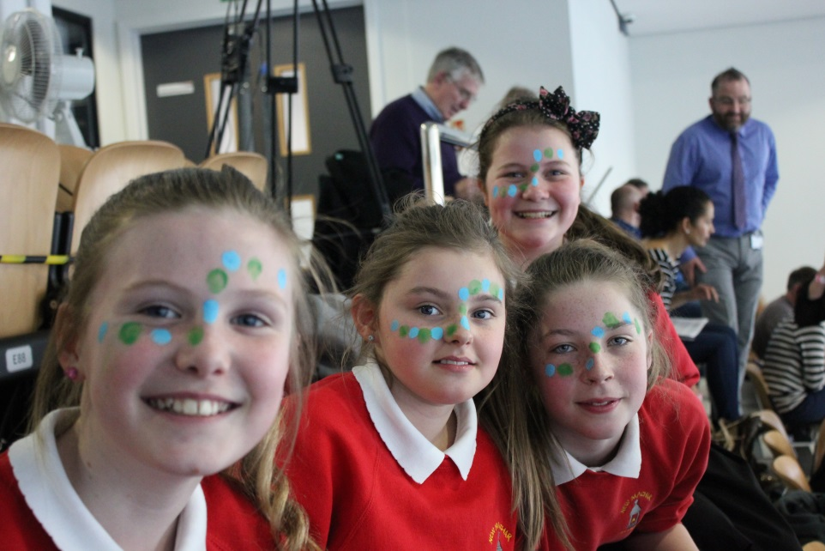

**Upcoming Events**

* Our Parent Council AGM will be held on Tuesday 5th May 2015 at 7pm. All welcome!
* P7 pupils visit Dyce Academy on Wednesday 6th May.
* Annual Parents’ Evenings will be held on Wednesday 6th and Thursday 7th May from 5-7pm.
* Our Concert for Parents will be held on Monday 18th May 2015.
* Our Over 50s Concert will be held on Tuesday 19th May 2015.
* P7 pupils visit Dyce Academy on Wednesday 20th May for a Numeracy and Mathematics event.
* Saturday 6th June is our SUMMER FAYRE!

**Superstar Sophie!**

On the 8th March 2015 our very own Sophie (P4/5) took part in a Scottish Gymnastics Competition competing against 59 other gymnasts from all over Scotland. Sophie performed in the vault, beam, bars, floor and range and conditioning. Sophie received an individual bronze for range and conditioning and a GOLD for all round!

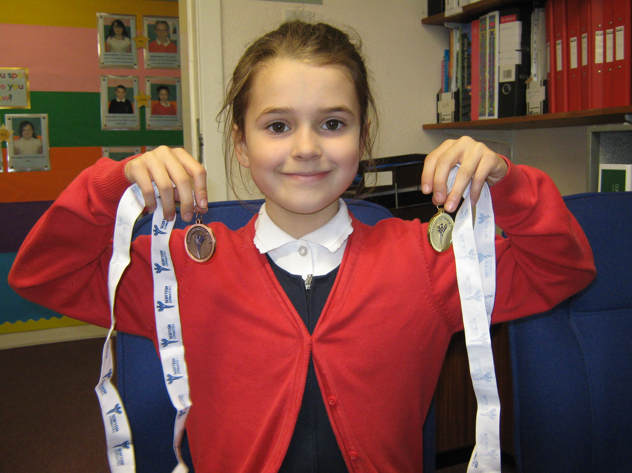

Massive congratulations to Sophie, WELL DONE!



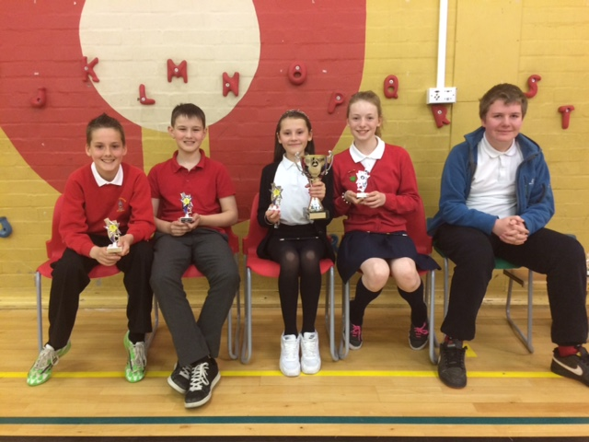On Friday 24th April at Dyce Primary School our quiz team was triumphant! James, Scott, Kirsty, Chloe and Daniel all played their part in a nerve shattering contest that saw us beat Dyce Primary by a single point in the final round to clinch victory. Once again, our New Machar pupils were a credit to our school. They will now go on to compete in the District competition in Banchory in May.

Your ideas, views and opinions are very important to our school. If you would like to comment on any of the items within this newsletter or anything else, please do so below and return this page to the school office. Alternatively, you can email us at **newmachar.sch@aberdeenshire.gov.uk** with *Have Your Say* as the subject heading.

Many thanks!

Your Child’s Name and Class (optional)

Your name and relationship to child (optional)

Comments -

**Have Your Say!**

April 2015